# FABEC Reports

# Tracking

# System

Project Documentation Submitted

To the Faculty of School of

Computer Science and Information Technology

Of

Asia Pacific College

In Partial Fulfillment of the Requirements for the subject

Applied Projects 2 or Software Development

By:

Ave Jay Moradillo

Jhun Michael Tabudlong

Markim Africa

**Narrative**

**Executive Summary**

First of all the Fort Bonifacio church

**Introduction**

**Client Profile**

**Fort Bonifacio Evangelical Church**

Fort Andres Bonifacio Evangelical Church or widely known as FABEC is a Christian church built to serve the community of the Armed Forces of the Philippines as well as the local civilians in the area to spear-head a Christ-centered, spirit-filled, and Mission-oriented community of believers.

**Project Organization**

1. **Project Team**

* Ave Jay Moradillo
* Jhun Michael Tabudlong
* Markim Africa

1. **Project Professor**

* Mr. Manuel Sebastian Sanchez

1. **Project Advicers**

* Mr. Sir Jayvee Cabardo

**Client’s Mission and Objective**

**Vision and Mission**

Mission "To Know Jesus Christ make Him know to the Army community for a blessed fellowship Spirit-filled worship and fruitfull service."

Vision "United FABEC-A Christ- centered Spirit-filled,Bible-based and Mission-oriented community of believers."

**Project Objectives**

-This System will give the user(s) (members of the church) the benefit to access the schedule of events, online prayer request, and ministry updates of the church.   
-This system will also have an online registration for those who wants to be members of the church.   
-The administrators of this system will be given the privilege to post, review, and keep track of the reports about prayer request, membership, financial statements, events, and church ministry.

**Purpose of the Project**

* The purpose of the project is to develop a web application that will handle their current organizational process such as membership, events reservation, church activities, and etc. With the use of this application the current process f*l*ow of the church will be more efficient

**Rationale of the Project**

**The Current Process Flow**

Our first priority about our project is to research about the clients problems given to us and to create a fitting solution for them. By interviewing them, we learned that their current system still manually provides assistance to the members of church. Our Client demands this project because he wants to update all the current members of the FABEC to the newest church activities, tracking events, financial statements, members, feedback of the members and prayers. The process starts with the applicant who’s going to be members by registering and by providing his information for the council to approve his membership request. Then if he/she is already a member of the church he/she will have privilege to use the prayer request, event registration, and access the upcoming events. And also for the Finance Department they can also use our database for tracking financial status of the church but if they login as admin not as regular user.

#### 

#### User Information Needs

* Church members information
* Church events information
* Financial status information(Admin)

#### How the Information is being processed

The system will manage church member’s information, financial status (admin), manage the events and assist people who want to join. The member can only view the website including the event calendar, news, and etc.

## Systems Features and Functions

### Software Environment

a. Programming Languages

PHP Framework (Drupal)

b. Specific Software

Moodle Xampp

c. Operating System

Windows 7 / 8

d. Other Software

Notepad++ DIA Visual Paradigm Project Libre

### Hardware Environment

1.80 GHz processor with 2GB RAM and at least 2GBof free disk space.

### Networking and Security

#### Security

Security - With the login function, the system is secured from outside threats. Host

#### Server

Local Server Xampp Server will be used to deploy the system.

### Application System Modules

1. Prayer Request

2. Online Membership

3. Event Registration

4. Calendar

5. News feed

6. Tracking system for their events, church needs, financial statements, etc.

**Data Flow Diagrams**

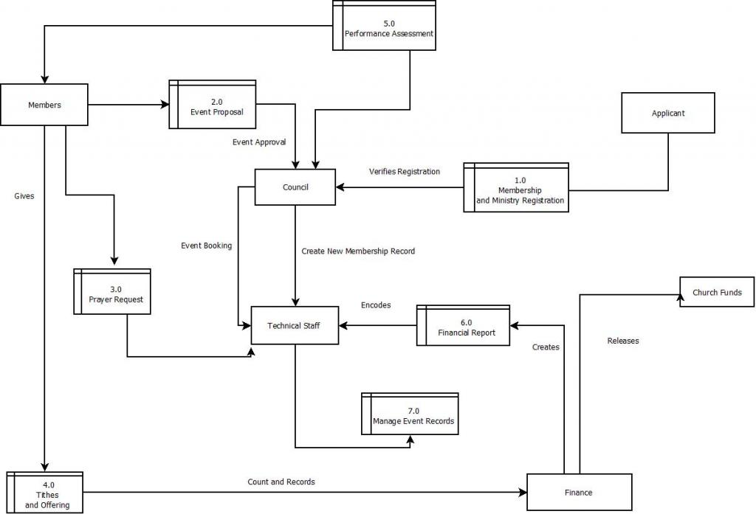

**UML**

**Use case Diagram**

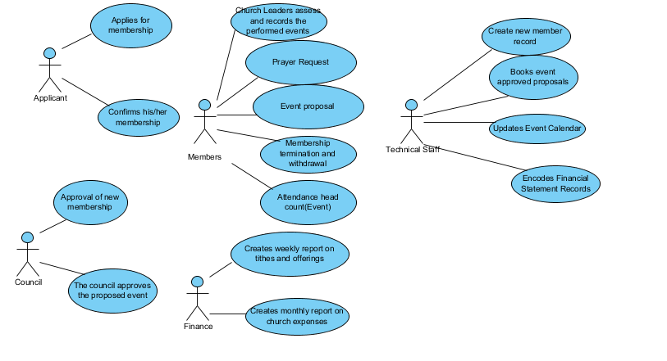

Class Diagram

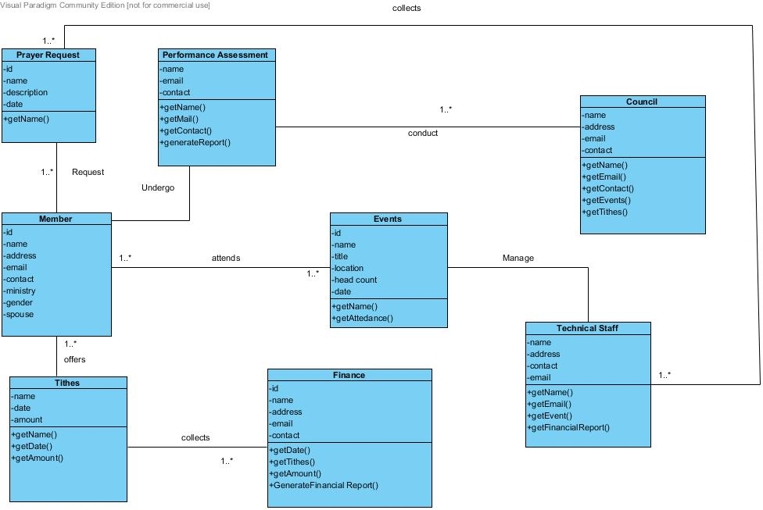

Communication Diagram

Prayer Request

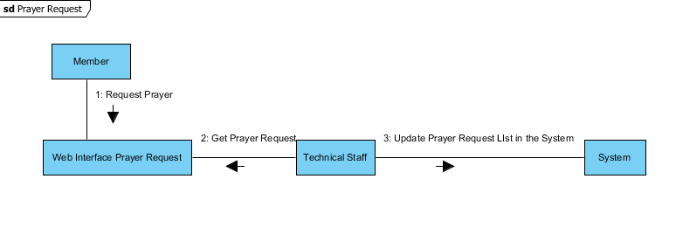

Event Proposal

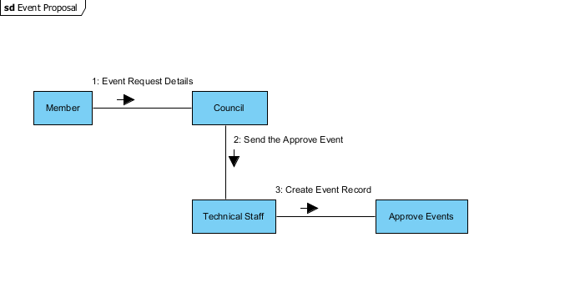

Membership with Application form

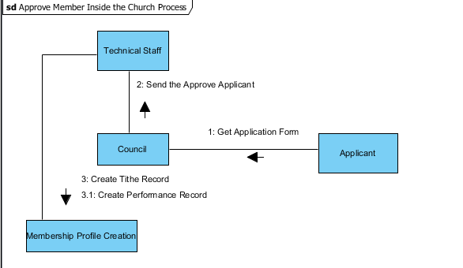

Activation of newly approved member

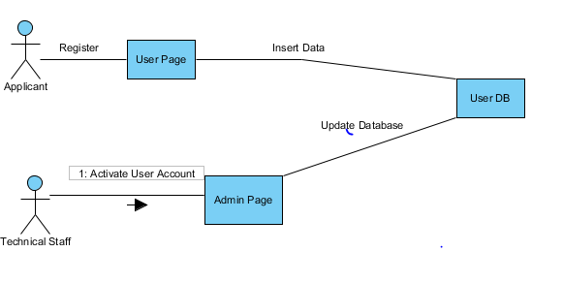

Attendance Record

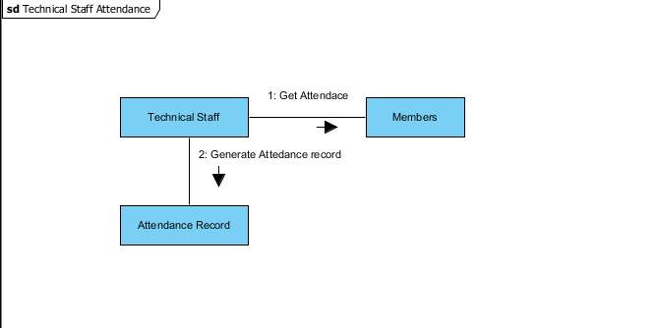

Financial Report

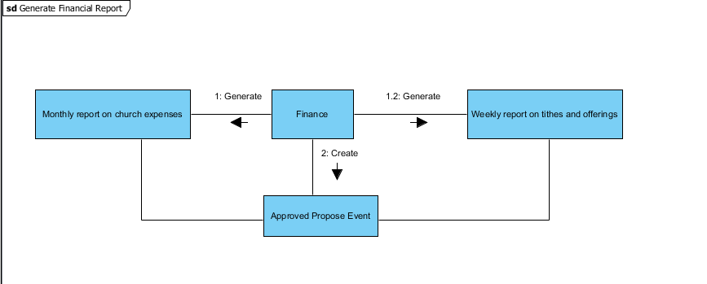

Component Diagram

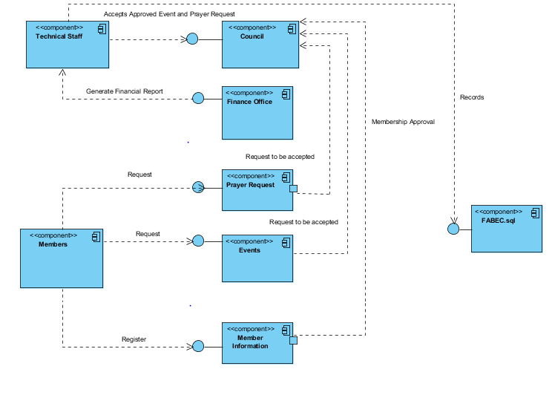

Composite Diagram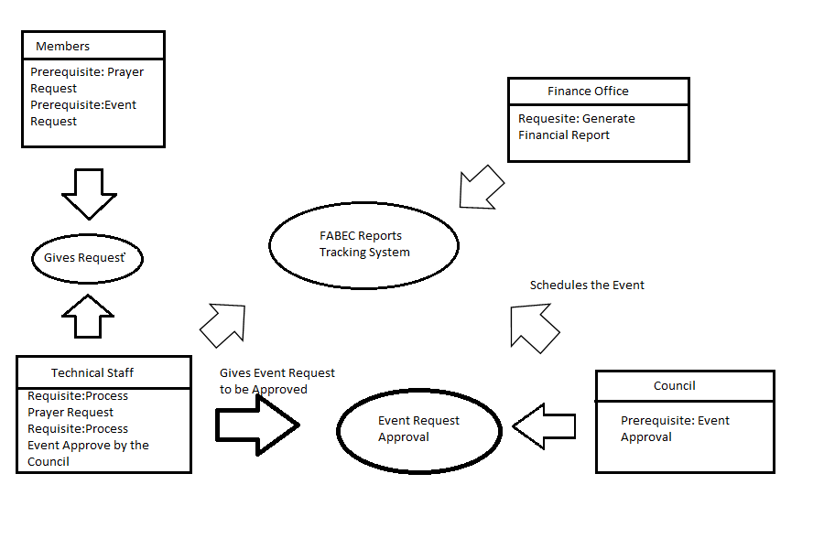

Deployment Diagram

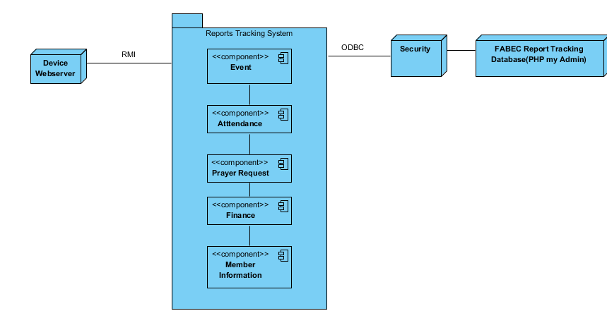

Interaction Overview Diagram

Event Proposal and Prayer Request

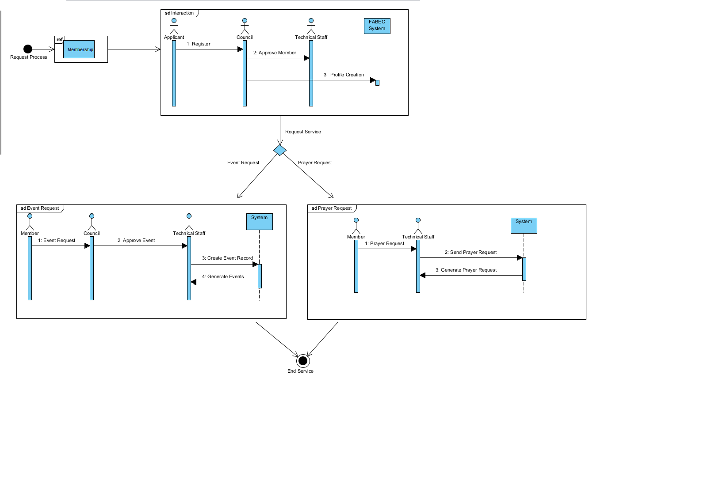

Performance Assessment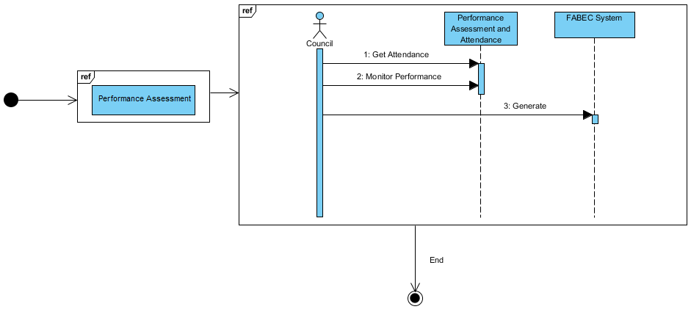

Financial Report

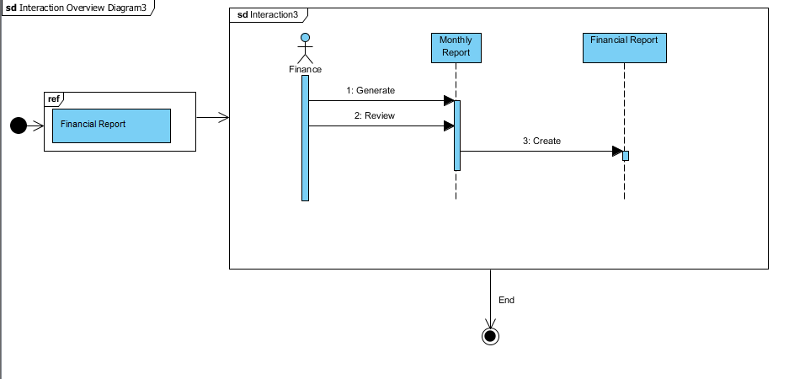

Object Diagram

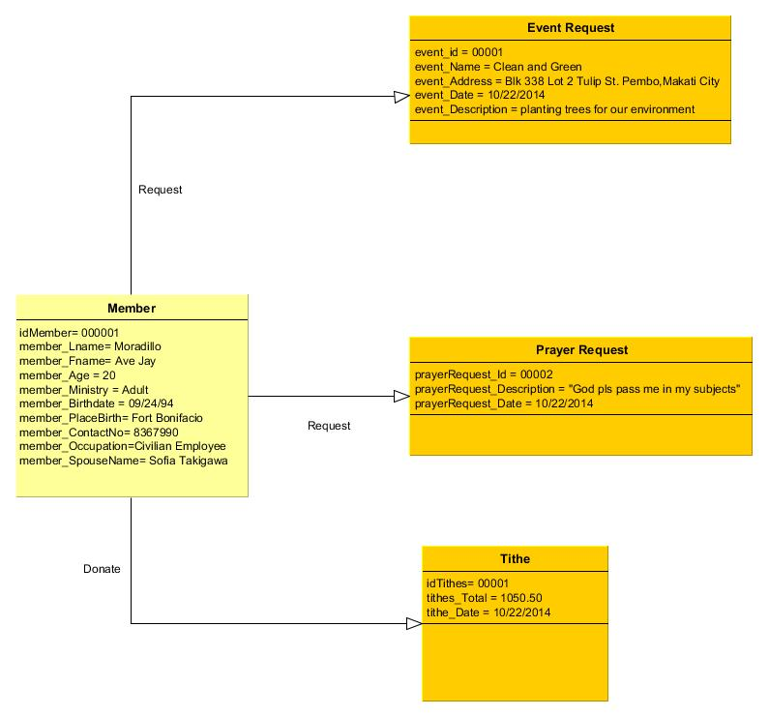

Package Diagram

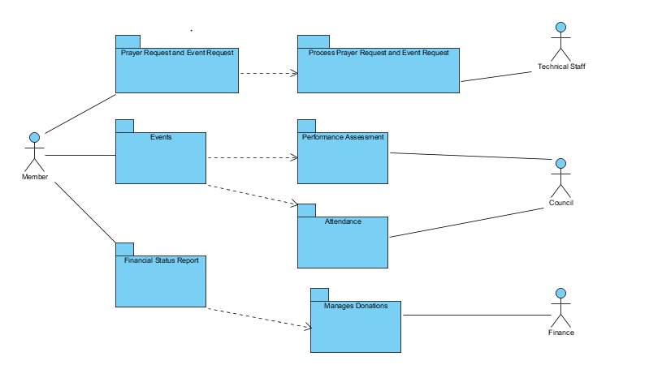

Sequence Diagram

Approve Members

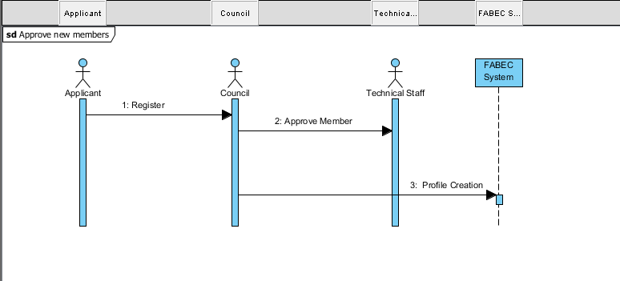

Event Reques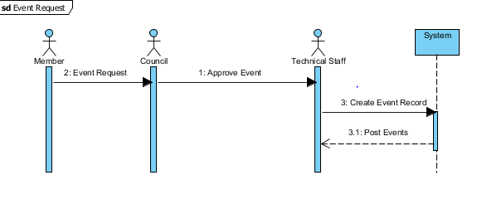

Prayer Request

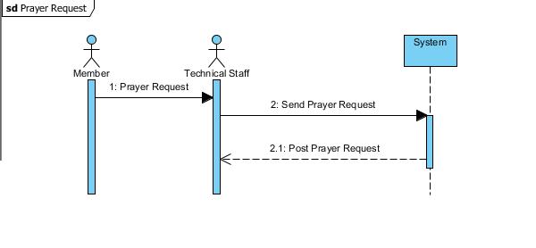Financial report

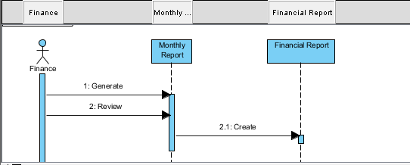

Performance Assessment

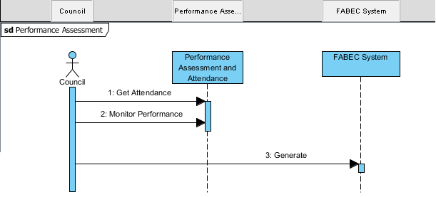

State machine Diagram

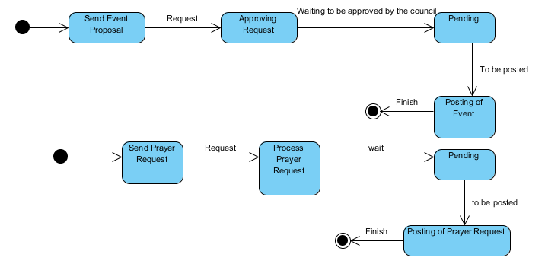

Event Proposal & Prayer Request

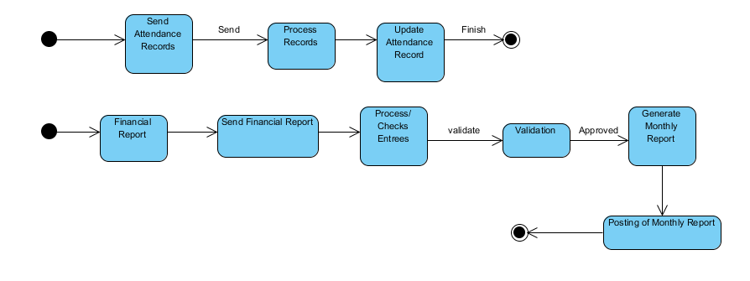

**Timing Diagram**

Membership Application (Inside System)

Update Member Database

Applicant Register

Create member record

Approve Application

Review Applicant Details

30 minutes 1 week 1 day 30 minutes 30minutes

Event Member Request

Update Event Database

Create event record

Approve Event Request

Review Event Details

Member Event Request

30 minutes 1 week 1 day 30 minutes 30minutes

Performance Assessment

Update Performance Assessment in System

Ministry Performance Assessment Report

Process Performance Assessment in System

Review Performance Assessment in System

Compile Performance Assessment Report

1 month 1 days 1 day 1 day 30mins

Prayer Request

Update Prayer Request Database

Create Prayer Request Record

Review Prayer Request Details

Approve Prayer Request

Member Prayer Request

40 minutes 15 minutes 20 minutes 30 minutes 30minutes

Financial Report

Generate Annual Finance Report

Update Finance Database

Receive Report

Encode Financial Report

Review Report

Compile Financial Report

1 month 1 week 1 week 30 mins 30 mins 30mins

**ERD**

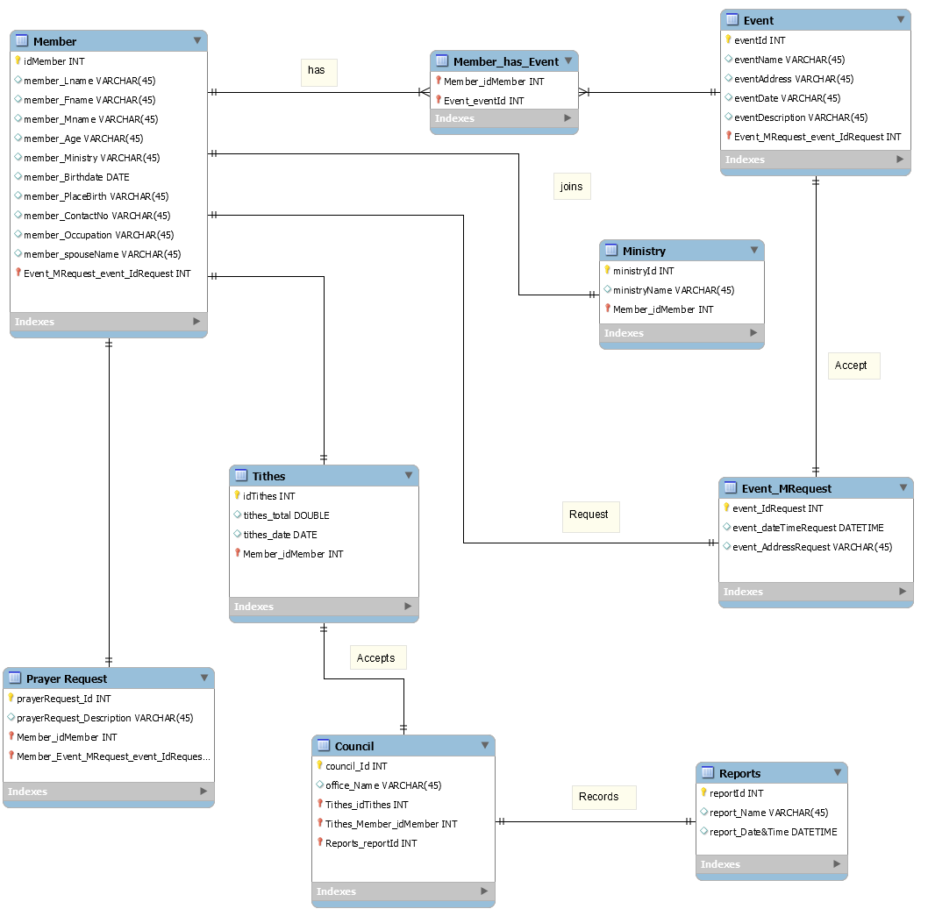

Data Dictionary

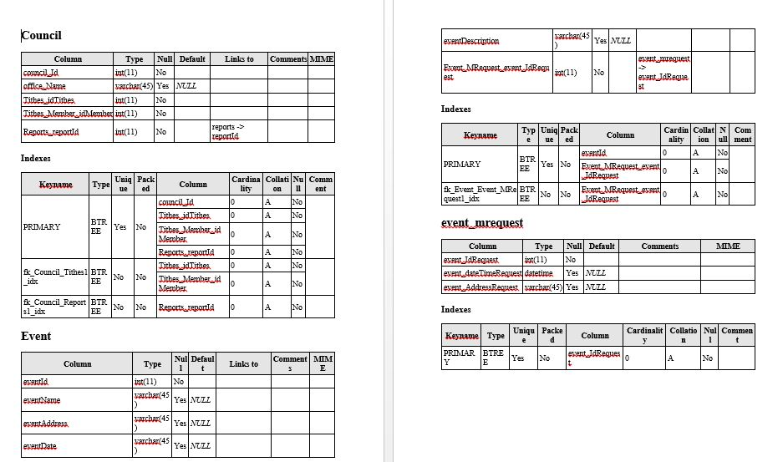

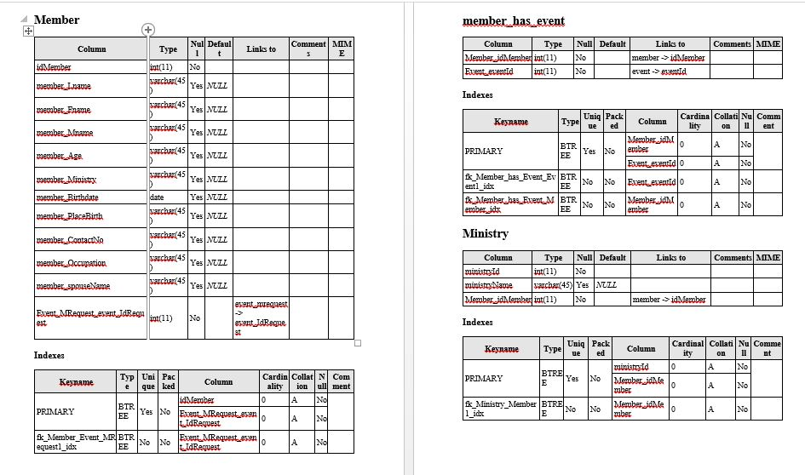

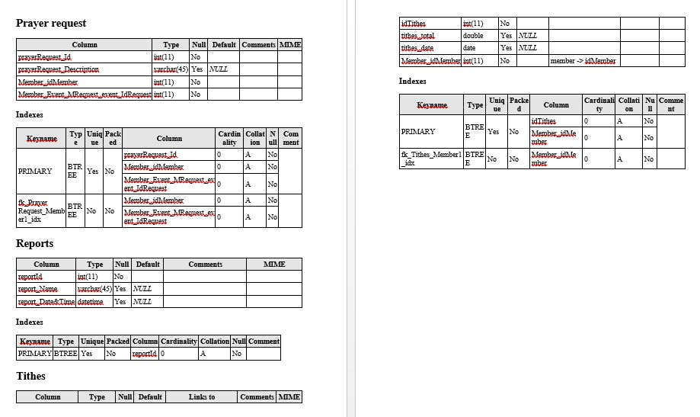

Screenshots:

